# Exercise 1 – Project Plan

## Description

Title:

So Cal Sightseeing

Two sentences describing the content:

The site will give some sightseeing locations that might be interesting to certain users that range from the border to san luis Obispo/kern/san Bernardino county line

Short description of design concepts - what is the user experience at this Web site supposed to be?

The site will be a simple sight with simple interface where the user can experience ease of use while becoming knowledgeable in unique sites around the region.

## GAS Analysis

### 2.1 Goals

Developer Goals:

* Show integrated multimedia website that gets you an A in the class
  + Have a photo slide show where the user can see pictures of the site being described.
  + Show some video of what you can do in the area. Short history
* Display your multimedia work
  + Display pictures in a way were downloading does not take a long time
  + Do not allow for auto playback as soon as the page starts to load. Irritates users
  + Use CSS Sprites to limit download times
* Explain results
  + Site must be user friendly to the point where a 5 year old can understand it. gets the user interested to the point where the user will want to go and see it.

User Goals:

* Have them read at least three different unique locations where they can at least be able to understand what makes the location unique. Allow them to see some photos of the area around the unique site. Allow them to see video of the site with a brief explanation. Encourage them to travel locally.

### 2.2 Audience

Photos

 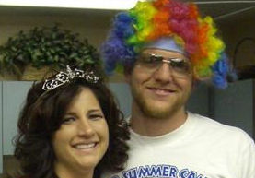 

and brief (paragraph) description of user. Persona.doc will have a detailed description.

Ranges from young adults of around 20 years to people who enjoy travelling up to the age of 99. Any person who is willing to go and explore the region to see what unique areas are there in the region.

### 2.1 Scope

Topic of Website – What is your topic? Can be same description as above.

The topic will mostly consist of places of where people can go visit. The point of the site is to try to get people interested in travelling in the local region.

Scope – What will the site include. How will pictures, sound, flash and video be incorporated into the site?

The site will include flash video and pictures. They will be incorporated into the places of interest. For example if I put a description of downtown LA I will put a video of a unique site such as angles flight as video and pictures of the farmers market across the street.

Outside of Scope – What will you not be doing?

I will not be doing is sound such as background noises to give clues to things on the site as well as background music since those two things tend to annoy people the most.

## Site Activities / Use Cases

Narrative walkthroughs of what the user will do. 2 primary and 2 secondary

What the user will do is that he will arrive on the main page and see a picture of a unique place such as angels fight. The user the will be giving a small description along with a link that has a bigger description on its appropriate webpage where video will also be show as well as additional pictures of the point of interest. I have not decided if I will allow comments on the page of the unique site.

## Site Map and Wireframe

**Include:**

* global navigation - will use a simple navigation since the users will get to confused if too much is added
* local navigation
* content area(s) – on the side of the web page
* focal point - where will user's attention be drawn? – center right of the webpage.
* Mockups of where your mm content will be

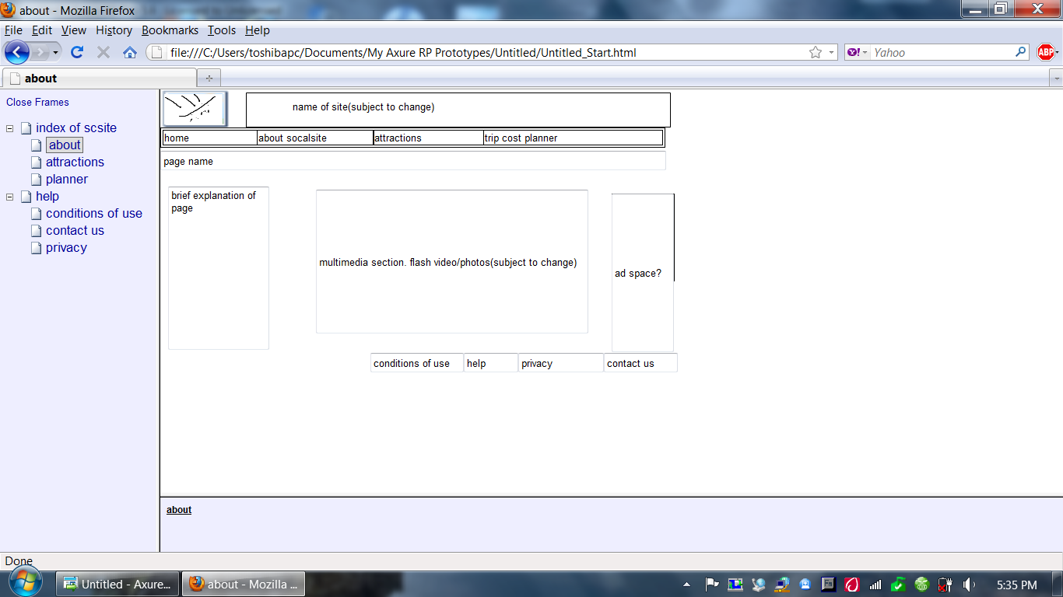

## Design Details

Branding – logo & header- the icon will be a logo that I made that looks like a mountain. The logo will have some traveling appeal to it as well

Nav Strategy- simple horizontal navigation with a bing search box(if it is free to use)

Site Color Scheme- white background

Landmarks/Graphics- a landmark will be MT baldy as a background picture in the logo.

Fonts – the font will be Arial.